## Barometer

For the barometer we recommend the Vaisala PTB330. It provides reliable pressure measurement in a wide range of applications. Digital outputs RS232 and RS422/485 (optional) can be selected. There is also a local digital display available.



*: For more information we refer you to the Vaisala PTB330 manual*

The vaisala PTB300 will be connected to the serial port of a moxa that is connected to the NavVision system. In NavVision you can go to tools/configuration/serial/serial lan ports and there choose the vaisala PTB330 protocol from the drop down menu (see Figure 2‑1). For more information on how to install and set-up the Moxa, we refer you to the “software installation and commissioning manual”.

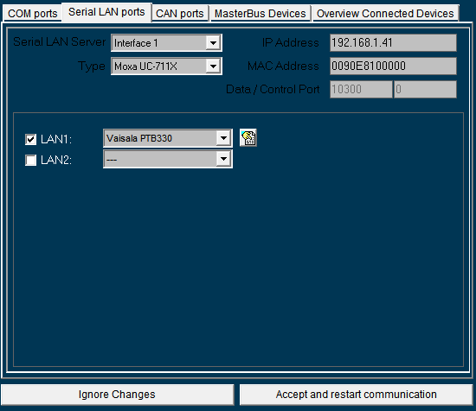

Figure 2‑1: Vaisala PTB330 on moxa